Authentication Documentation
William Seeley
October 8, 2020
Southern New Hampshire University
CS-499-Q1529 Computer Science Capstone 20EW1

Authentication Documentation
Authentication.py is simply a program to try to log into. It was created just within the time of this course. A user will try to log in with a username and password to match against a stored username/password. The stored passwords are encrypted with sha-256 so the program will hash the entered password into sha-256 and compare results if the username matches. If the sha-256 hashes match, it can be assumed the password entered is the same, and so the user is successfully logged in. All-in-all, I think this demonstrates the usefulness of encryption algorithms and why it is better to store hashes of passwords rather than the passwords itself.
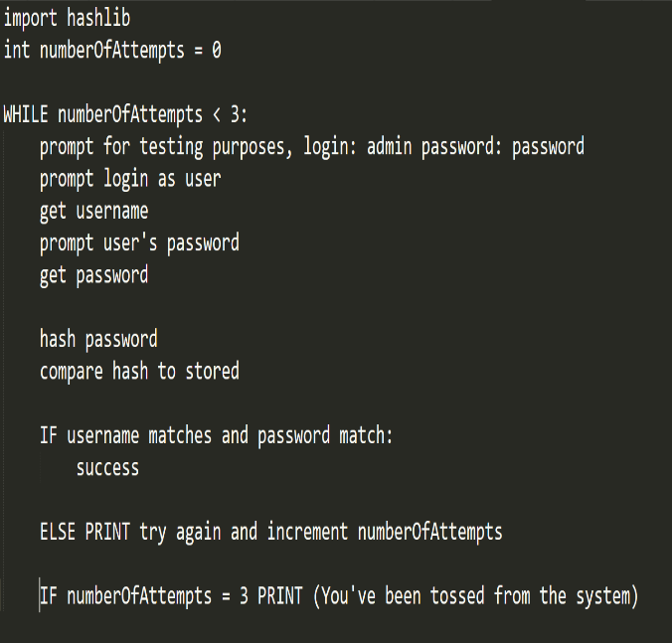
I was originally working with this with Pickle to create an encrypted username/password database, but the more I learned about Pickle, it suggested that it was rather dependent on user environments, so I dropped that in favor of portability. As an encrypted environment, it still wasn’t hard to discern important information (like the usernames and hashes) just by opening Figure 1 Pseudo Code
it in a text file, so the importance of Pickle also seemed rather negligible. While the program limits the user to three attempts, it would be an off-line environment either way, so a potential attacker can review the Pickle or the source code and grab the hash regardless and try to brute force the hash at their leisure. Using sha-256 rather than md5 will slow significantly slow down those efforts, though it remains the best defense is a strong password.
Figure 2 A Pickle-Encrypted File - Still Legible
